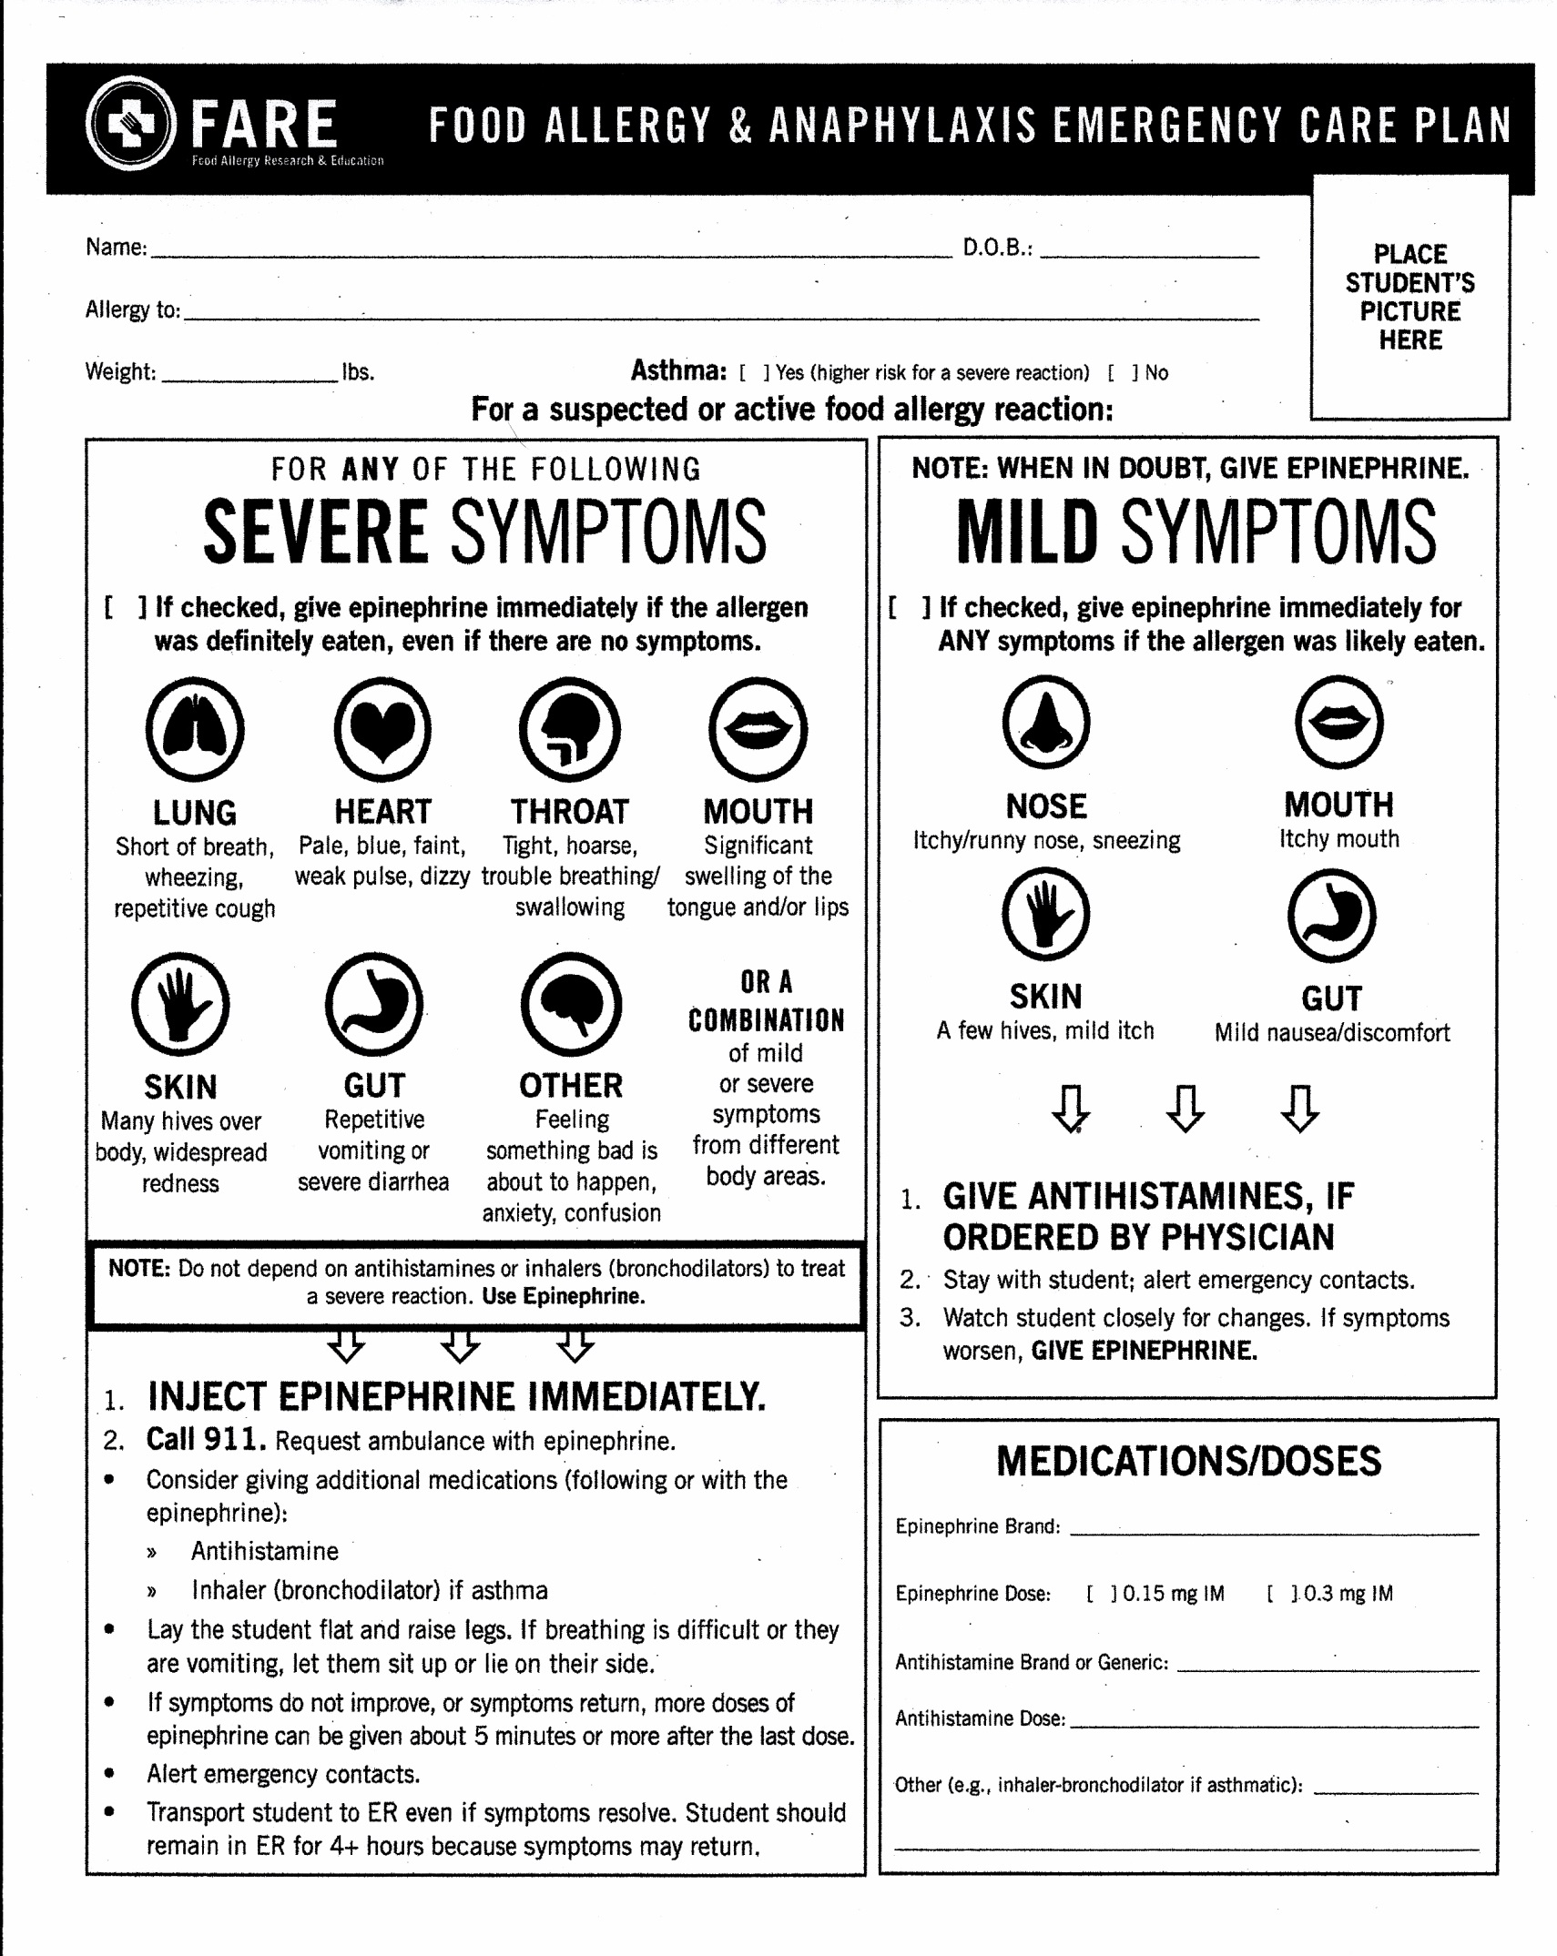
[Type a quote from the docume[Type a quote from the document or the summary of an interesting point. You can position the text box anywhere in the document. Use the Drawing Tools tab to change the formatting of the pull quote text box.]
Asthma: ( ) Yes (higher risk for a severe reaction) ( ) No
For a suspected allergic reaction:
To be completed by Physician
Physician signature required on back/ Parent signature required on back

Physician Complete
nt or the summary of an interesting point. You can position the text box anywhere in the document. Use the Drawing Tools tab to change the formatting of the pull quote text box.]

